PROJECT-2
Find top 3 competators by MULTI AI agents
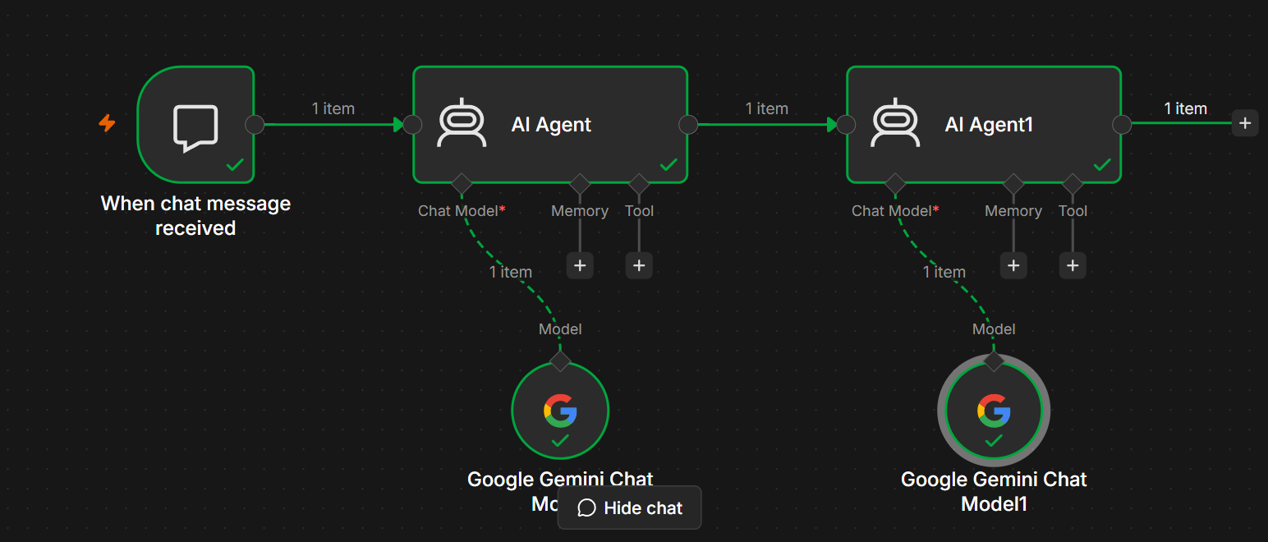
----------------------------------------------=--------------------------------------------------------
Project Information
Project Title: Multi-Agent AI Workflow using Google Gemini in n8n
Platform: n8n
AI Models: Google Gemini Chat Model
Workflow Type: Sequential Multi-Agent AI System
Purpose:
This workflow demonstrates a multi-agent architecture where two AI agents collaborate sequentially to process user requests. The first AI agent analyzes and prepares the user's query, while the second AI agent refines, validates, or enhances the response before returning the final output.

1. Overview
This workflow is designed to simulate a collaborative AI system using multiple AI agents. Instead of relying on a single language model, the workflow chains two AI agents together.
- AI Agent 1 receives the user's message and performs the initial analysis or response generation.
- AI Agent 2 receives the output from Agent 1, improves or validates it, and produces the final response.
This architecture is useful for complex tasks that benefit from multiple stages of reasoning or review.

2. Workflow Architecture
User
│
▼
When Chat Message Received
│
▼
AI Agent 1
│
▼
Google Gemini Chat Model
│
▼
AI Agent 2
│
▼
Google Gemini Chat Model
│
▼
Final Response
│
▼
User

3. Workflow Components
Node 1: When Chat Message Received
Purpose
The When Chat Message Received node acts as the trigger for the workflow. It starts automatically whenever a user sends a message through the chat interface.
Example Input
Explain Artificial Intelligence.
or
Write a professional email requesting leave.
Output
The user's message is forwarded to AI Agent 1.

Node 2: AI Agent 1
Purpose
The first AI agent performs the initial understanding and processing of the user's request.
Responsibilities
- Understand the user's intent.
- Generate the first draft of the response.
- Break down complex questions.
- Summarize or organize information.
- Prepare structured output for the next agent.
Connected Model
Google Gemini Chat Model
Example
Input
Explain Cloud Computing.
Output
Cloud Computing is the delivery of computing services such as servers, storage, databases, networking, and software over the internet.
This response is passed to AI Agent 2.

Node 3: Google Gemini Chat Model (Agent 1)
Purpose
This Large Language Model powers AI Agent 1 by generating the initial response based on the user's input.
Capabilities
- Question answering
- Summarization
- Content generation
- Code generation
- Text analysis
- Brainstorming

Node 4: AI Agent 2
Purpose
The second AI agent receives the draft response from AI Agent 1 and improves or validates it.
Responsibilities
- Review the initial response.
- Improve clarity and readability.
- Correct grammatical errors.
- Expand explanations.
- Add examples.
- Verify completeness.
- Produce the final response.
Example
Input from Agent 1
Cloud Computing is the delivery of computing services over the internet.
Final Output
Cloud Computing is the delivery of computing services such as servers, storage, databases, networking, software, and analytics over the internet. It allows users to access scalable computing resources on demand without managing physical hardware. Popular cloud providers include Amazon Web Services (AWS), Microsoft Azure, and Google Cloud Platform (GCP).

Node 5: Google Gemini Chat Model (Agent 2)
Purpose
This model supports AI Agent 2 by refining and enhancing the response generated by Agent 1.
Capabilities
- Proofreading
- Response enhancement
- Content refinement
- Detailed explanations
- Formatting improvements
- Error correction

4. Complete Workflow
User sends a message
│
▼
Chat Trigger
│
▼
AI Agent 1
│
▼
Google Gemini Chat Model
│
▼
Initial Response
│
▼
AI Agent 2
│
▼
Google Gemini Chat Model
│
▼
Enhanced Final Response
│
▼
User

5. Example Input
Write a professional resignation letter.

6. AI Processing
Stage 1 – AI Agent 1
- Understands the request.
- Generates a draft resignation letter.
Stage 2 – AI Agent 2
- Reviews the draft.
- Improves tone and formatting.
- Ensures professionalism.
- Returns the polished version.

7. Example Output
AI Agent 1
Dear Manager,

I would like to resign from my position.
Thank you.

Regards,
John
AI Agent 2
Subject: Resignation Letter

Dear Manager,

Please accept this letter as my formal resignation from my position, effective two weeks from today.

I sincerely appreciate the opportunities, support, and experiences I have gained during my time with the company. Working with the team has been both rewarding and valuable for my professional growth.

I will do my best to ensure a smooth transition of my responsibilities before my departure.

Thank you once again for your guidance and encouragement. I wish the organization continued success in the future.

Sincerely,

John

8. Technologies Used
Technology | Purpose
n8n | Workflow Automation Platform
When Chat Message Received | Workflow trigger
AI Agent | Workflow orchestration
Google Gemini Chat Model | Natural Language Processing
JSON | Data exchange format

9. Workflow Advantages
- Improves response quality through multiple AI review stages.
- Separates responsibilities across specialized AI agents.
- Produces more accurate and polished outputs.
- Easy to extend by adding more AI agents or external tools.
- Supports educational, business, and customer support use cases.
- Enables modular AI workflow design.

10. Use Cases
- Content writing and editing.
- Code generation and code review.
- Customer support assistants.
- Document drafting and proofreading.
- Research and report generation.
- Educational tutoring.
- Business proposal creation.
- Technical documentation.

11. Future Enhancements
- Add Simple Memory or Vector Memory for context-aware conversations.
- Integrate Google Search (SerpAPI) for real-time information retrieval.
- Connect to Google Drive or Notion for document storage.
- Add Slack, Microsoft Teams, or WhatsApp notifications.
- Use a Structured Output Parser for consistent JSON responses.
- Include RAG (Retrieval-Augmented Generation) with a vector database for organization-specific knowledge.
- Add logging and analytics to monitor AI performance.

12. Conclusion
This multi-agent AI workflow demonstrates how n8n can orchestrate multiple Google Gemini-powered AI agents to solve complex tasks collaboratively. The first agent focuses on understanding and generating an initial response, while the second agent refines and enhances the output to deliver a more accurate, polished, and comprehensive answer. This modular design improves response quality, simplifies maintenance, and can be expanded with additional agents, memory, or external tools to build advanced AI assistant applications.

